- December's modest uptick in UK inflation was largely driven by one-off and temporary factors. While we'll probably see a further rise in January, all the major components will be pushing inflation downwards by the spring. We think that inflation is still on track to return to the Bank of England's 2% target in April.
- Evidence of a further cooling in pay growth will be welcomed by the Monetary Policy Committee, and we continue to expect the first rate cut to come in Q2. But our proprietary sentiment data suggests pay growth will stabilise in early-2024, and we see the risks as being skewed towards the MPC loosening policy more slowly.
With the Office for National Statistics publishing the final official pay and inflation figures before February's Monetary Policy Committee meeting, the week's data releases looked key to whether the MPC would tack in a more dovish direction. In the event, the data was broadly consistent with the MPC reining in its hawkish rhetoric. The slowdown in pay growth continued. Meanwhile, though inflation edged up slightly, it didn't alter the likelihood of a steep drop in price pressures in the coming months.
Pay growth had slowed in the autumn, partly because late-summer's stronger readings had dropped out of the headline (three-month average of the annual rate) measure. Private sector regular pay growth slowed further in the three months to November, to 6.5% from 7.2% in October. This was the lowest rate since summer 2022. This added to the likelihood that pay growth was well below the Bank of England's forecast of a 7.2% increase in Q4. Meanwhile, the shape of the ONS series remains broadly consistent with other measures such as the Indeed Wage Tracker, which suggested pay growth declined again in December, and our own proprietary sentiment data, developed with Penta (Chart 1).
Chart 1: The easing in pay pressures is consistent with our proprietary indicator and the survey evidence
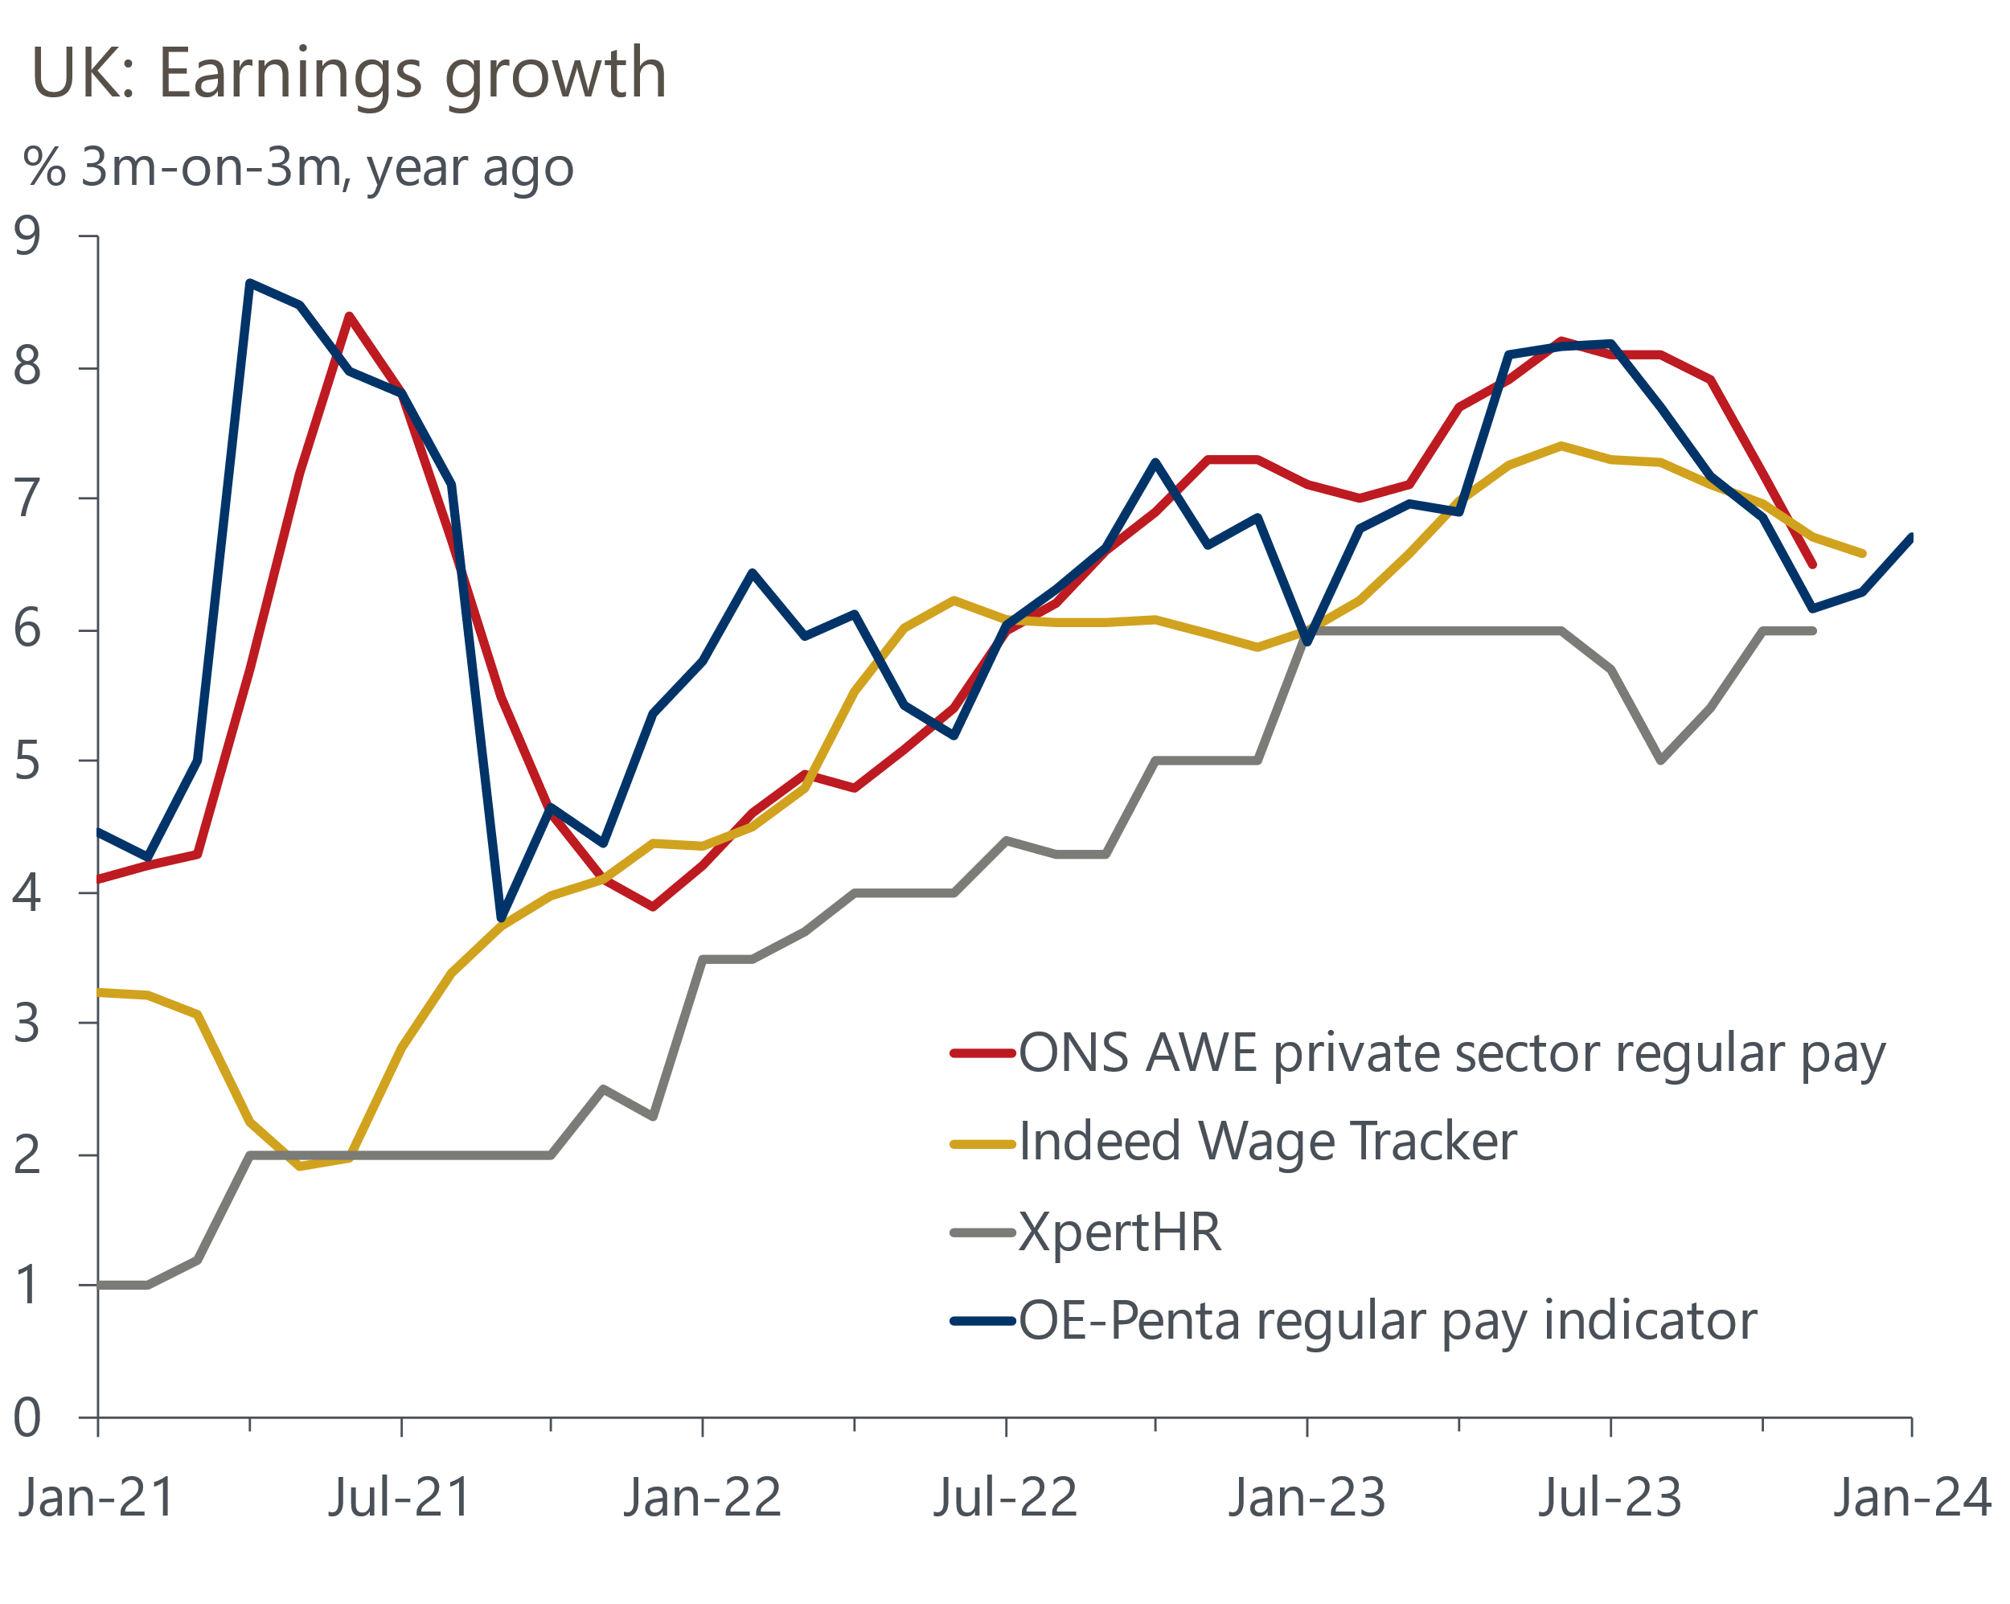
Source: Oxford Economics, Haver Analytics, Indeed, Xpert HR, Penta

This week's inflation release showed that the CPI measure surprised on the upside in December, rising slightly to 4%, from 3.9% in November. But December's small increase was largely driven by the month's large rise in tobacco duty, as well as a huge jump in the volatile air fares category which should unwind in January.
Given the nature of December's rise, inflation is still on track to fall back to the BoE's 2% target in April. For sure, inflation is likely to edge up again in January as the higher energy price cap takes effect and core inflation is boosted by the comparison with a particularly low outturn in the same month in 2023.
But the bigger picture is that all the major components will either be dragging on CPI inflation or making smaller positive contributions by the spring. Indeed, wholesale gas prices have continued to fall in recent weeks, and we now estimate that the Ofgem energy price cap will fall by 14% in April. We expect oil prices to stabilise at lower levels than last year, meaning the drag on headline inflation from the petrol category should persist throughout the year. Food price inflation is likely to slow markedly in the coming months as more strong base effects come into play. Meanwhile, core pressures should continue to soften, particularly as firms pass on their lower energy costs to consumers.
With inflation running well below the BoE's forecast in Q4 and likely to undershoot even further in early-2024, we expect the BoE to lower its forecast significantly when it publishes its new projections on February 1 (Chart 2).
Chart 2: We expect inflation to be back to target in April, 18 months earlier than the BoE's forecast
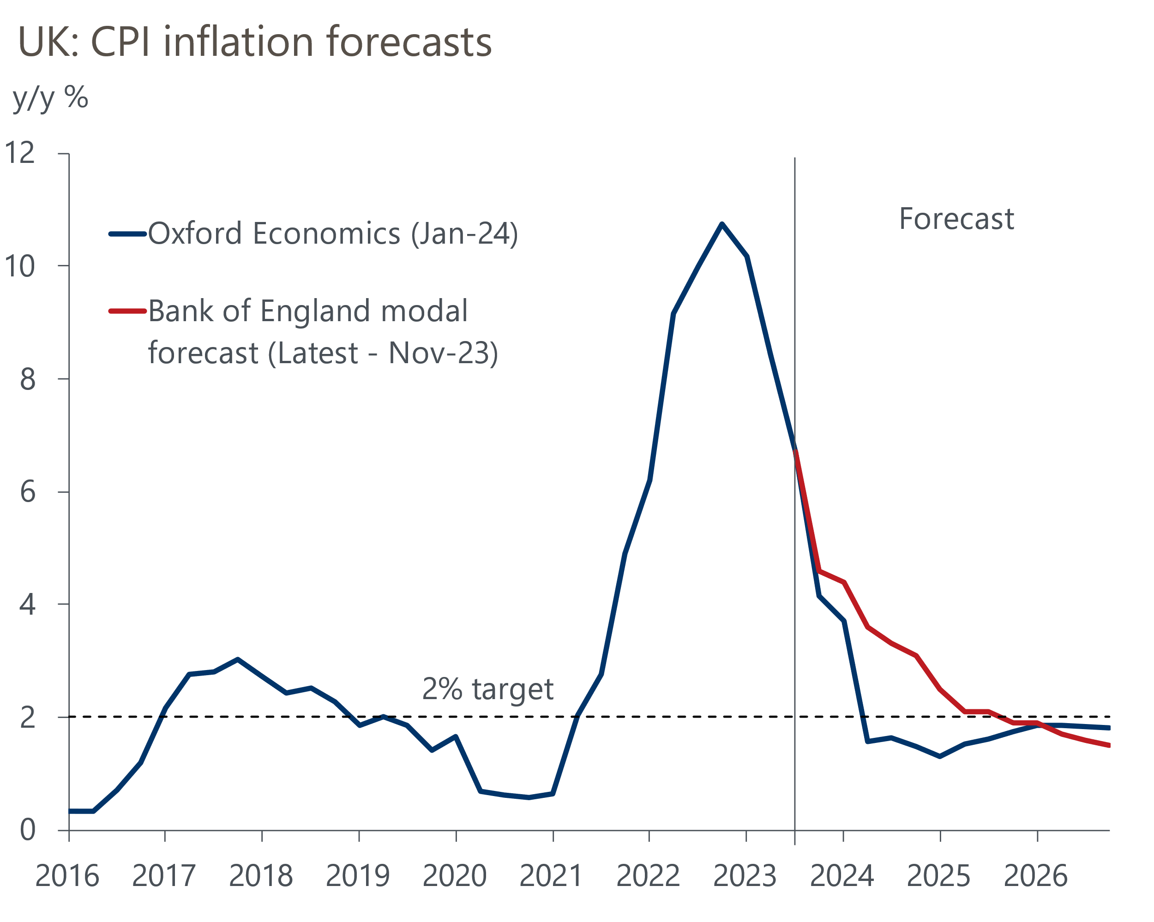
Source: Oxford Economics, Bank of England
The extent to which the BoE lowers these forecasts, and whether the MPC changes its language around policy needing to be restrictive for "an extended period of time", will offer some insight into how close we are to rate cuts. Though the case for looser policy looks strong, we think the MPC will be cautious and want to see clear evidence that pay growth is coming down before it moves. This points to the MPC beginning to cut rates in May. But the risks are skewed towards a later move, particularly if the signal from our nowcast proves correct and pay growth stabilises at relatively high rates in early-2024, rather than continuing to cool.
The improved outlook for inflation should be a positive for the retail sector. The ONS reported a shock 3.2% m/m fall in retail sales volumes in December, and attempted to explain it as largely a timing issue with consumers purchasing Christmas gifts earlier than usual. But the data doesn't back that narrative and the outturn was far weaker than the results in relevant business surveys. So we think the most likely explanation is that this is the latest evidence of how noisy the retail sales data can be, and expect December's weakness will quickly reverse. We remain relatively upbeat about the sector's fortunes this year, with lower inflation set to boost household spending power and cause a steady improvement in retail sales.

The week ahead
A relatively quiet week begins with the release of December's public finances data. Given government borrowing in December 2022 was inflated by energy support to households, the deficit in December 2023 should have fallen in y/y terms. As a result, we expect public sector net borrowing (excluding banks) was £15.2bn in December.
December's S&P Global/CIPS surveys provided further evidence of a two-speed economy, with a strong pickup in services activity, but little momentum in manufacturing production. If the surveys' forward-looking indicators are anything to go by, December's drop in new orders suggests manufacturing output is likely to remain subdued in the near term. So we think the flash manufacturing PMI will slip to 46.0 in January. In contrast, the services survey reported tentative signs of a pickup in client demand while business activity expectations in the sector rose. As a result, we expect the flash services PMI to rise slightly to 53.7. This would leave the compositive PMI at around 52.3.
Table 1: Week ahead calendar
Date | Events | Period | Measure | Unit | Previous | Forecast
Jan 23 | Public finances | Dec | PSNB ex | £bn | 14.3 | 15.2
Jan 24 | S&P Global/CIPS manufacturing | Jan | PMI | % bal | 46.2 | 46.0
Jan 24 | S&P Global/CIPS services | Jan | PMI | % bal | 53.4 | 53.7
Jan 24 | S&P Global/CIPS composite | Jan | PMI | % bal | 52.1 | 52.3
Source: Oxford Economics

Key forecasts
Table 2: UK forecast overview
(Annual percentage changes unless specified)
 | 2021 | 2022 | 2023 | 2024 | 2025 | 2026
GDP | 8.7 | 4.3 | 0.3 | 0.6 | 1.6 | 1.9
Private consumption | 7.5 | 4.8 | 0.6 | 0.9 | 1.8 | 1.9
Fixed investment | 7.4 | 8.0 | 2.3 | -3.2 | 0.5 | 2.8
Government consumption | 14.9 | 2.3 | 0.6 | 4.3 | 2.1 | 1.6
Exports of goods and services | 4.9 | 9.0 | -0.3 | 0.1 | 2.8 | 2.4
Imports of goods and services | 6.1 | 14.6 | -1.3 | 2.0 | 3.3 | 3.0
Industrial Production | -3.9 | -3.5 | -0.4 | 0.4 | 0.9 | 1.5
Consumer prices | 2.6 | 9.1 | 7.3 | 2.1 | 1.5 | 1.8
Unemployment rate (%) | 4.5 | 3.7 | 4.1 | 4.5 | 4.3 | 4.0
Current a/c balance (% of GDP) | -0.5 | -3.1 | -2.6 | -2.5 | -2.6 | -2.7
Government balance (% of GDP) | 7.2 | 4.4 | 5.4 | 3.3 | 2.9 | 2.4
Cen. bank policy rate (%, EOP) | 0.25 | 3.50 | 5.25 | 4.25 | 3.25 | 2.25
10yr govt. bond yield (%, EOP) | 0.97 | 3.67 | 3.54 | 3.59 | 3.37 | 2.92
Exchange rate (US$ per £, EOP) | 1.35 | 1.20 | 1.27 | 1.26 | 1.28 | 1.31
Exchange rate (euro per £, EOP) | 1.19 | 1.13 | 1.15 | 1.16 | 1.15 | 1.15
Source: Oxford Economics
Table 3: Quarterly forecasts for the UK
 | 2023 |  |  |  | 2024
 | Q1 | Q2 | Q3 | Q4 | Q1 | Q2 | Q3 | Q4
GDP (% year) | 0.4 | 0.3 | 0.3 | 0.2 | 0.2 | 0.4 | 0.8 | 1.0
CPI inflation (% year) | 10.2 | 8.4 | 6.7 | 4.2 | 3.7 | 1.6 | 1.6 | 1.5
Bank Rate (%, EOP) | 4.25 | 5.00 | 5.25 | 5.25 | 5.25 | 4.75 | 4.50 | 4.25
10yr gilt yield (%, EOP) | 3.47 | 4.39 | 4.46 | 3.54 | 3.75 | 3.64 | 3.61 | 3.59
US$ per £ (EOP) | 1.24 | 1.27 | 1.22 | 1.27 | 1.25 | 1.25 | 1.25 | 1.26
Euro per £ (EOP) | 1.14 | 1.17 | 1.15 | 1.15 | 1.16 | 1.16 | 1.16 | 1.16
Source: Oxford Economics

Latest Country Economic Forecast:
January 18, 2024

Recent publications

Data Insights
Don't read too much into December's retail sales data
Inflation set to fall sharply despite December's upside surprise
Pay growth continues to cool
The economy returned to growth in November
Services PMI suggests the sector ended 2023 on a high

Research Briefings
Nowcast points to continued labour market resilience
Will the MPC cut fast or slow?
The boost from falling rates will be a slow-burner
Three reasons why inflation will swiftly return to target
Rethinking QE in light of large asset purchase losses

Contacts

Oxford Economics' UK team
- Andrew Goodwin - Chief UK Economist - agoodwin@oxfordeconomics.com
- Edward Allenby - UK Economist - eallenby@oxfordeconomics.com

